Evaluating quality and Quality Status

Evaluating quality
# Source: AI Source: Provided by: [Data Path: Persons Table -> ID Column: 1, Name_En Column: Motasem Essam] -> From: [ChatGPT] on [8/21/2025]
Evaluating quality means measuring how well something — in this case, software — meets defined standards, expectations, or requirements.
In software, it’s about checking:
- Does it work correctly? (Functionality)
- Is it easy to use? (Usability)
- Is it fast and stable? (Performance & Reliability)
- Is it secure? (Security)
- Will it keep working after changes? (Maintainability)

How We Evaluate Software Quality
# Source: AI Source: Provided by: [Data Path: Persons Table -> ID Column: 1, Name_En Column: Motasem Essam] -> From: [ChatGPT] on [8/21/2025]
We usually follow these steps:
- Define quality criteria – Based on standards (like ISO/IEC 25010) or client requirements.
- Measure – Use tests, metrics, and user feedback. Examples:
  - Bug count per release
  - Response time under load
  - Percentage of passed test cases
- Compare against benchmarks – Industry standards, competitor performance, or historical data.
- Report and decide – If it meets the target, it’s “good quality”; if not, it needs improvement.

Why It Matters
# Source: AI Source: Provided by: [Data Path: Persons Table -> ID Column: 1, Name_En Column: Motasem Essam] -> From: [ChatGPT] on [8/21/2025]
If we don’t evaluate quality:
- Users may face errors or frustration.
- Companies may face security breaches or financial loss.
- The product may fail in the market.

Quality Status

✅ Definition
# Source: AI Source: Provided by: [Data Path: Persons Table -> ID Column: 1, Name_En Column: Motasem Essam] -> From: [ChatGPT] on [8/21/2025]
Quality Status is a measure or indication of the current quality of a software product at a given point in time.
In simple terms: it tells how good or reliable the software is right now, based on testing results, defects found, and coverage achieved.
It is often reported in test reports to help stakeholders decide whether the product is ready for release, needs more testing, or requires fixes.

🔹 What Determines Quality Status
# Source: AI Source: Provided by: [Data Path: Persons Table -> ID Column: 1, Name_En Column: Motasem Essam] -> From: [ChatGPT] on [8/21/2025]
- Test Execution Results
  - Number of test cases passed, failed, or blocked.
- Defects Found
  - Number of critical, major, and minor defects.
  - Severity and impact of defects on the system.
- Coverage Metrics
  - Percentage of requirements, code, or features tested.
  - How much of the high-risk functionality has been covered.
- Risk Assessment
  - Are there unresolved risks that may affect the product?
- Compliance with Standards
  - Does the product meet functional, security, performance, and regulatory requirements?

🔹 Example of Quality Status
# Source: AI Source: Provided by: [Data Path: Persons Table -> ID Column: 1, Name_En Column: Motasem Essam] -> From: [ChatGPT] on [8/21/2025]
Project: Online Banking App
- Test Execution: 95% test cases passed
- Defects: 2 critical, 3 major open
- Coverage: 100% of critical requirements tested
- Risk: Payment module under high load not fully tested
Quality Status:
Moderate – core functionality works, but some critical issues remain; not yet ready for production.

💡 Key point:
# Source: AI Source: Provided by: [Data Path: Persons Table -> ID Column: 1, Name_En Column: Motasem Essam] -> From: [ChatGPT] on [8/21/2025]
Quality Status is a snapshot of software quality at a given time, helping decision-makers evaluate release readiness and risk levels.

is Quality Status is same Evaluating quality
# Source: AI Source: Provided by: [Data Path: Persons Table -> ID Column: 1, Name_En Column: Motasem Essam] -> From: [ChatGPT] on [8/21/2025]
Not exactly — they are related but not the same. Let me clarify:

🔹 Difference Between Quality Status and Evaluating Quality
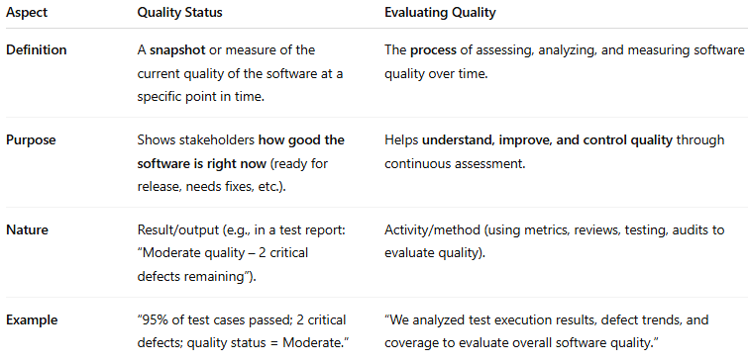
Aspect | Quality Status | Evaluating Quality
Definition | A snapshot or measure of the current quality of the software at a specific point in time. | The process of assessing, analyzing, and measuring software quality over time.
Purpose | Shows stakeholders how good the software is right now (ready for release, needs fixes, etc.). | Helps understand, improve, and control quality through continuous assessment.
Nature | Result/output (e.g., in a test report: “Moderate quality – 2 critical defects remaining”). | Activity/method (using metrics, reviews, testing, audits to evaluate quality).
Example | “95% of test cases passed; 2 critical defects; quality status = Moderate.” | “We analyzed test execution results, defect trends, and coverage to evaluate overall software quality.”

💡 Key Point
# Source: AI Source: Provided by: [Data Path: Persons Table -> ID Column: 1, Name_En Column: Motasem Essam] -> From: [ChatGPT] on [8/21/2025]
- Evaluating quality → what we do: analysis and assessment.
- Quality status → what we get: the outcome of that evaluation at a particular time.
Think of it like a health check:
- Evaluating quality = the doctor examining you, taking tests.
- Quality status = the report card saying “Your health is good/moderate/poor.”

